Overview

Switching to the Regular Console

Shutting Down the System

Adjusting Network Settings

# Overview

iSanté versions 9.0 RC2 and later include a new tool called “confconsole” which provides useful information and easy access to several system tasks. This tool is shown on the screen after the system boots up and replaces the initial console login prompt that appeared in older versions of iSanté.

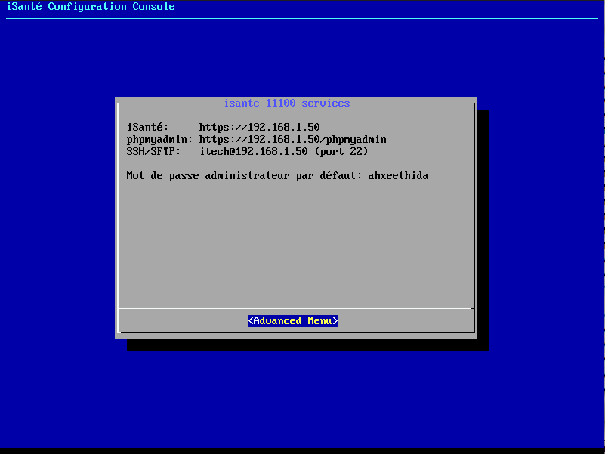

On the initial screen you will find the URL used to access the iSanté application as well as how to access several other resources on the system. The default administrator password generated during installation is also shown on the screen. This is the password used by the ‘admin’ accounts in iSanté and phpMyAdmin as well as for the ‘itech’ account on Linux. If the server will not be hosted in a secure location it is recommended that the password on these accounts be changed. The password is not shown for systems that were upgraded from 9.0 RC1 or older.

More functions are available in the **Advanced Menu**. It is possible to navigate to the **Advanced Menu** by either pressing the **Enter** key on the keyboard or by clicking on the text with the mouse.

# Switching to the Regular Console

The login console found in versions of iSanté prior to 9.0 RC2 is still available. To switch to it press ALT+F1. To switch back to confconsole press ALT+F8.

# Shutting Down the System

To shutdown the system first navigate to the **Advanced Menu**.

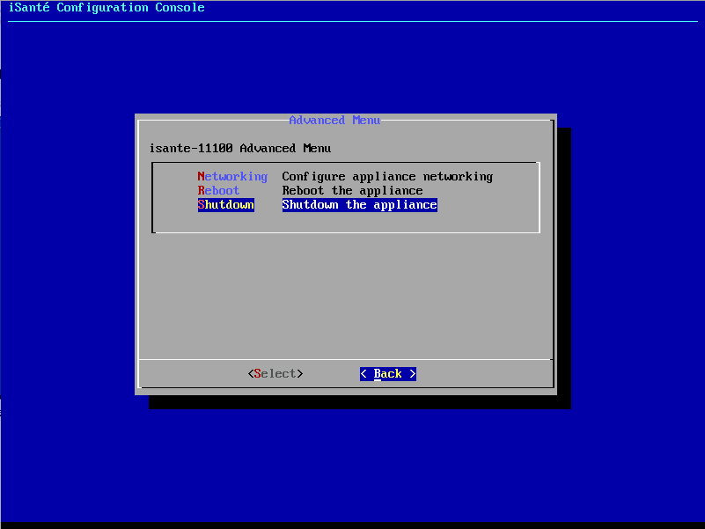

From there select the **Shutdown** option using the down arrow on the keyboard and press **Enter**.

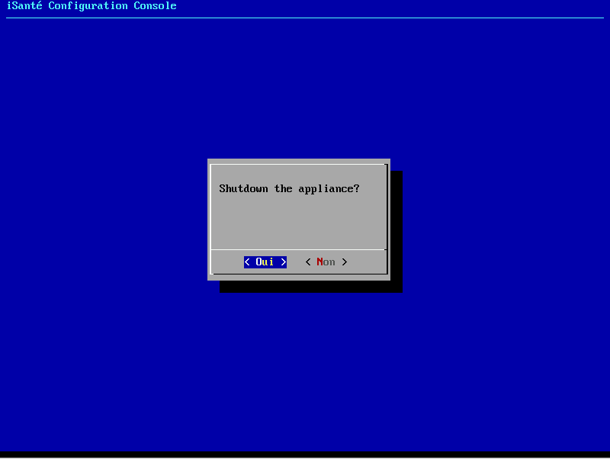

Press **Enter** at the confirmation dialog to start the shutdown. **It is important to shutdown the system this way to insure that all data has been saved correctly and to avoid damaging the system.**

# Adjusting Network Settings

The server’s IP address, default gateway, subnet mask and DNS servers can all be configured with confconsole. To do this first navigate to the **Advanced Menu**. From there select the **Networking** option and press **Enter**.

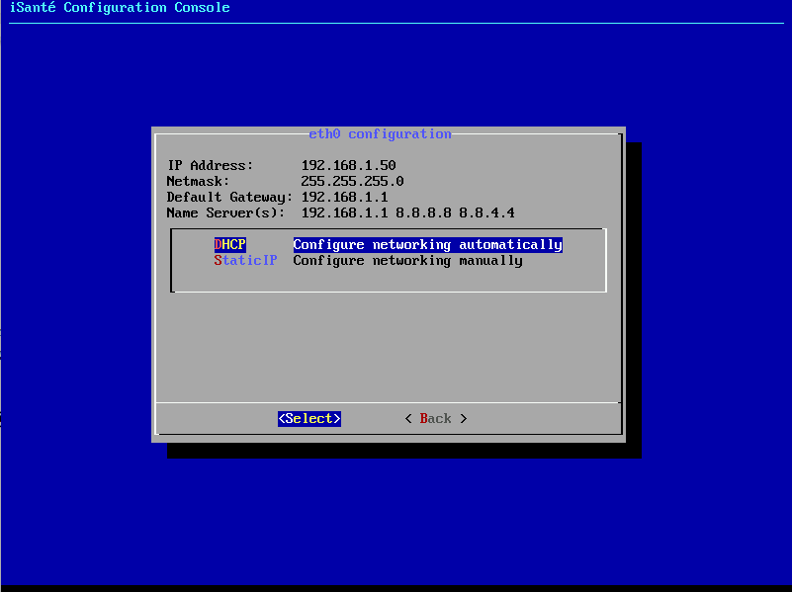

The networking screen shows the current network settings and has two menu item for **DHCP** configuration and **StaticIP** configuration. The default settings are shown in the image above.

Using **DHCP** for a production server is not recommended because the IP address can change unexpectedly. A static configuration similar or identical to the default one is recommended. To adjust the static settings first use the down arrow to select **StaticIP** and press **Enter**.

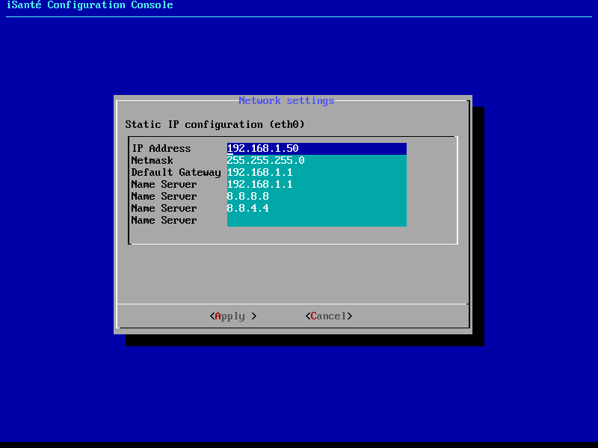

At this screen each setting can be adjusted using the keyboard. To select different fields use the up and down arrow keys or the mouse. Once the fields are adjusted pressing **Enter** will apply and save any changes.

Note that the name servers 8.8.8.8 and 8.8.4.4 are administered by Google. They are included by default to maximize reliability of DNS operations. It is recommended that 8.8.8.8 and 8.8.4.4 always be used as the second and third name servers, respectively.